

**Explore the World**

**Submitted By: Team 10**

**Aravind Sheri**

**Sharath Koppu**

**Aditya Soman**

**Banu Sudheer**

**Project Goal and Objectives:**

**Motivation:**

Traveling the world or visiting an unknown place is always exiting and very refreshing, because of the various local languages communication is the primary problem and traveling is very hard and it makes life difficult over there. Our Application provides a medium to communicate in any language and various other functionalities to make a tourist’s life easy.

**Significance/uniqueness:**

This Application has the important functionality so called a medium to communicate with local people through text to text conversion and text to speech conversion. In this application Augmented reality is used to convert any image text to normal text and navigation is very easy so that it wouldn’t be any difficulty in navigating the world.

**Objective:**

Our Application will reduce the various barriers of a tourist to travel around the world and it will run on any platform to make life easy.

**System Features (Added Features):**

* Application has the main feature as language translation that is either text from user language to text of local language of various regions.
* User can register or sign in using username and password which are stored in firebase storage.
* User can register using login page where user should provide username and password and the user details will be stored in firebase.
* The main feature of our application is to translate the text that is entered by the tourist in the native language and translate the text entered to local language where tourist visited so that communication will not be a barrier.
* Tourist using the application can locate his position using the maps in the application and use to navigate to various positions.
* Another important feature of the application is to extract the data from an image so that tourist can take a photo of a text using his phone and provide the photo as input and extract the data that is editable.
* Another cool feature in the application is image analysis which is very much useful in understanding various traffic signals in various remote areas that are pretty much different and get insights from various images.
* To overcome the barrier of communicating with the local people where they cannot read we added a feature to convert the translated text into voice so that it is easy and understandable to the local people.

**Services and API Used:**

* Yandex API for Text to Text language translation.
* Firebase for storing the details of the user and email authentication.
* Google OCR plugin for extracting text from image.
* Google maps API for maps and user location and navigation.
* Geolocation for getting the user current location.
* Clarifai for visual detection and getting insights from an image.
* Google API for text to speech of the translated text.

**Detail Design of Features:**

**Wireframes and Mockups:**

**Below are the screenshots for the wireframes and Mockups:**

1. **Login Page**

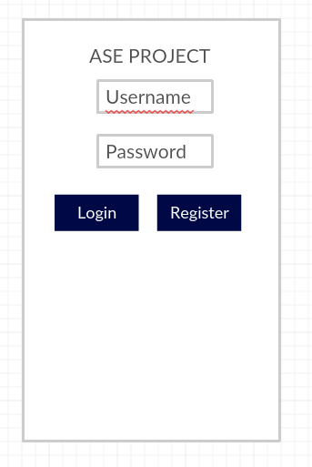

1. **Home Page**

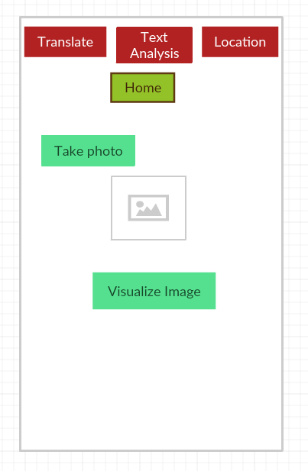

1. **OCR Plugin:**

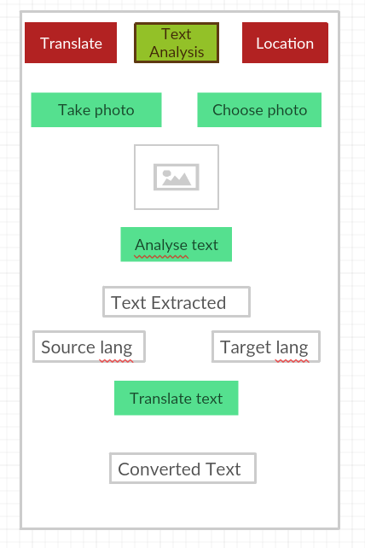

1. **Language Conversion:**

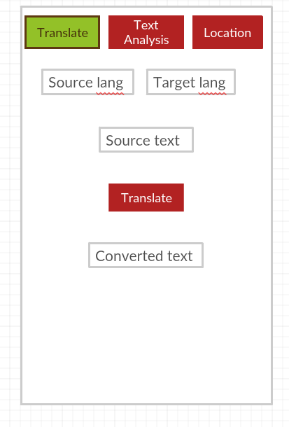

1. **Maps:**

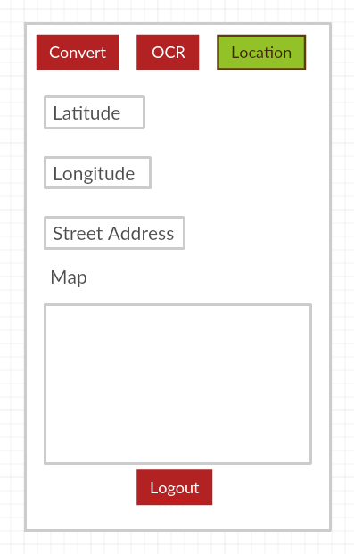

**Architecture Diagrams:**

1. **Class Diagram:**

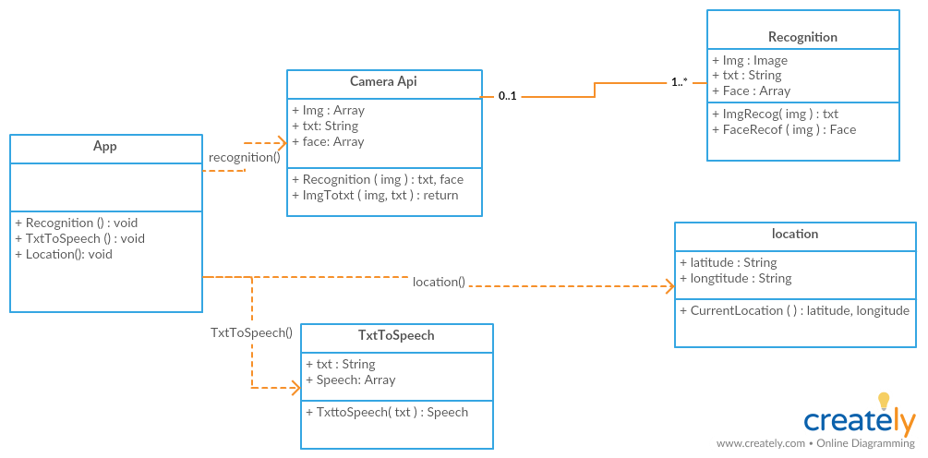

1. **Sequence Diagram:**

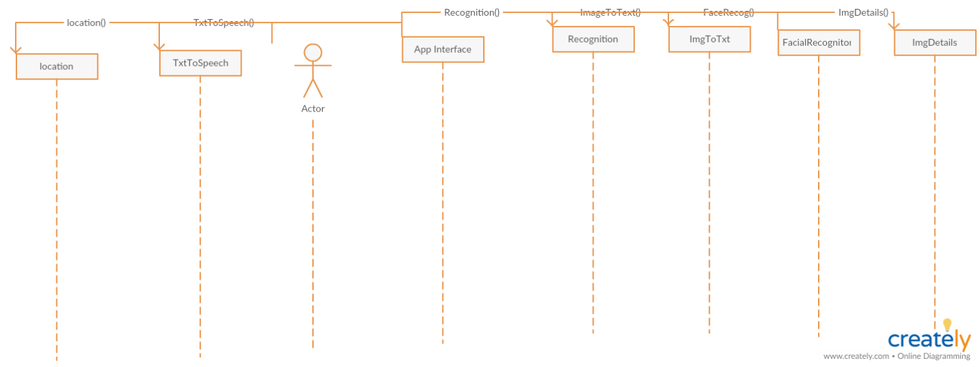

1. **Iteration-3 Architecture Diagram:**

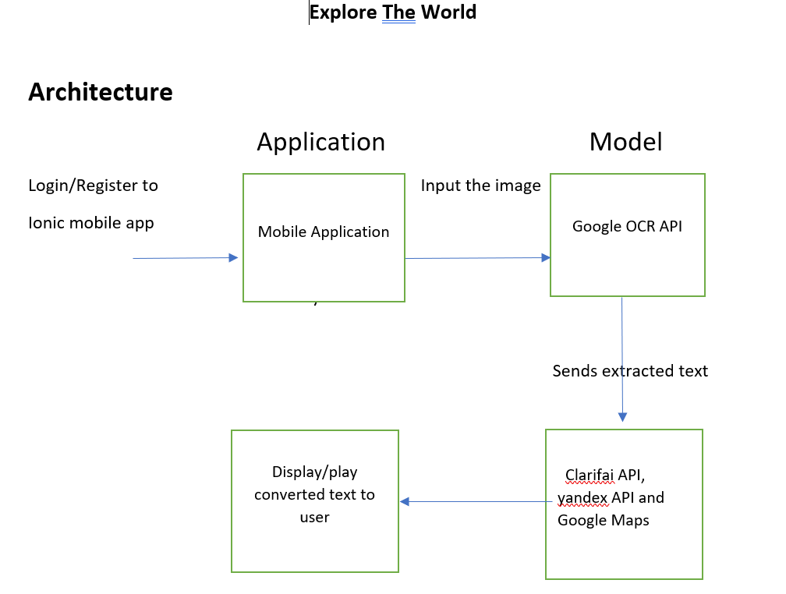

**Implementation:**

Created an application using Ionic framework so that the application is runnable in any platform and user friendly. Application has a login page where user will be able to login and use the services provided in the application and user will be able to register and the details are stored in Firebase and email authentication is used for logging into the application.

After login into the application tourist will be able to use various services like text to text translation, image prediction, Google Maps and text to speech

1. **Login Screen:**

User will be able to login into the application using email authentication provided by Firebase API.

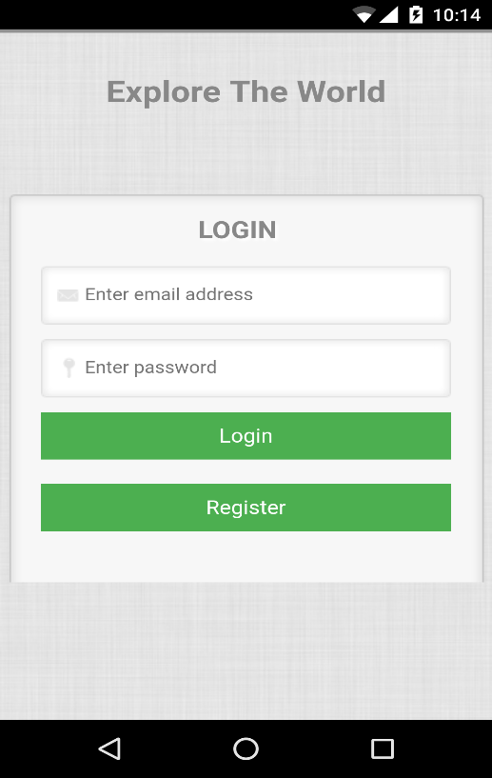

1. **Registration Screen:**

Registration of a user is done by using by the same login screen, when user provides email and password and clicks register the details will be saved in the Firebase database and the data is fetched when user logins using the email and password set at the time of registration.

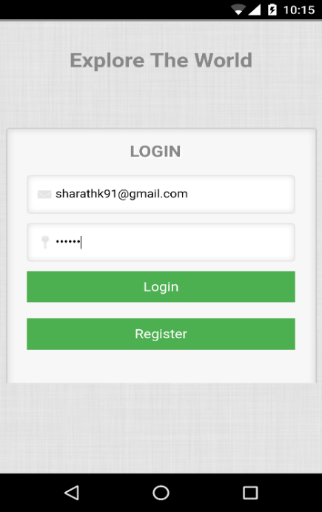 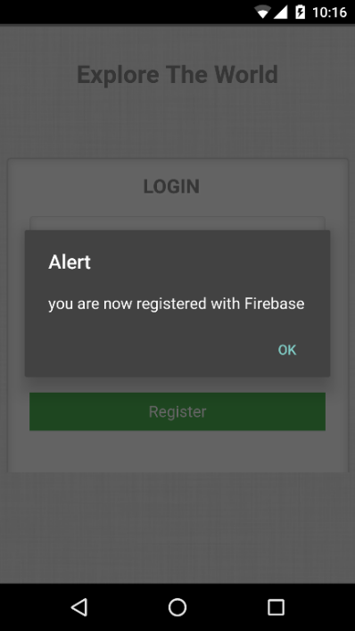

1. **Home Page:**

Home Page contains all the services of the application and tourist can use all the services that are required

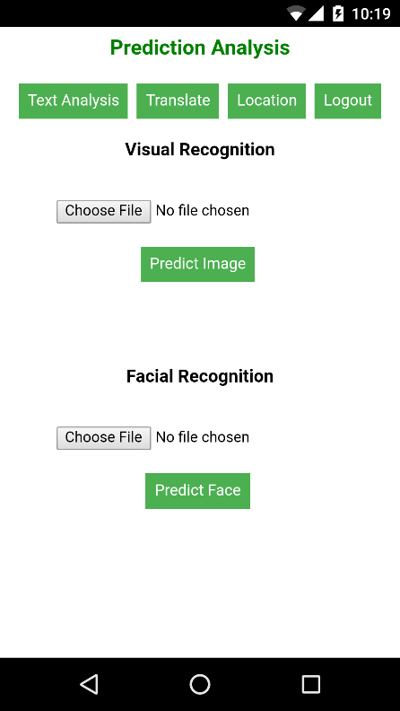

1. **Google OCR Plugin:**

OCR plugin is used to extract text from an image so that tourist can take a picture of an image and convert the text in the image to editable text. User can take a picture using camera of the device and select an existing image so that he can extract meaningful text from the image.

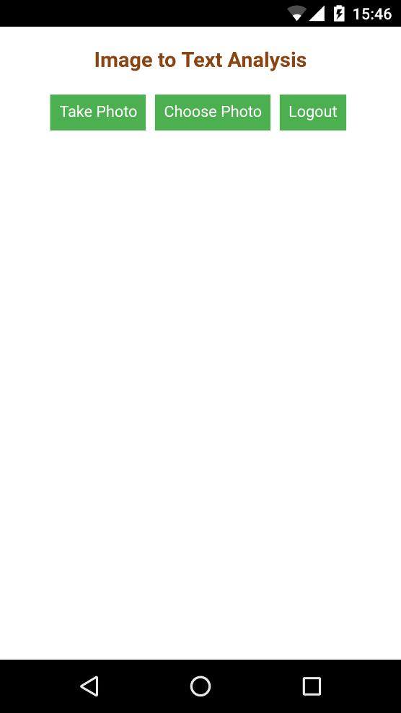 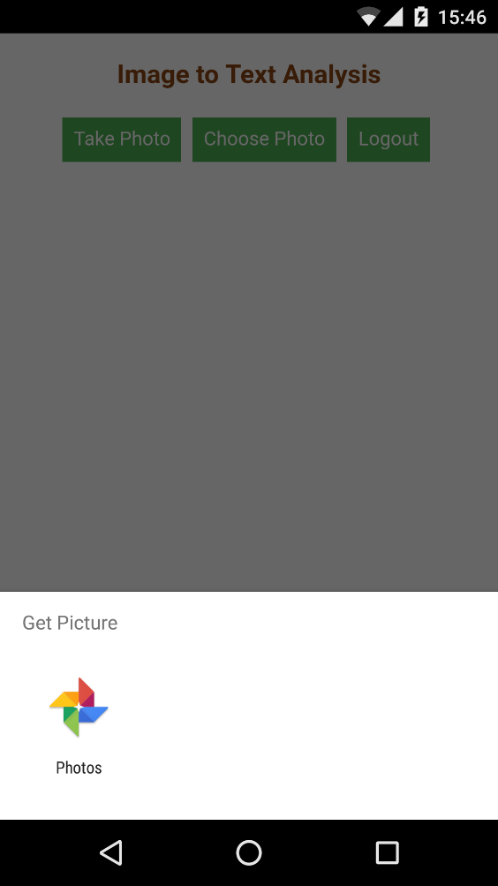

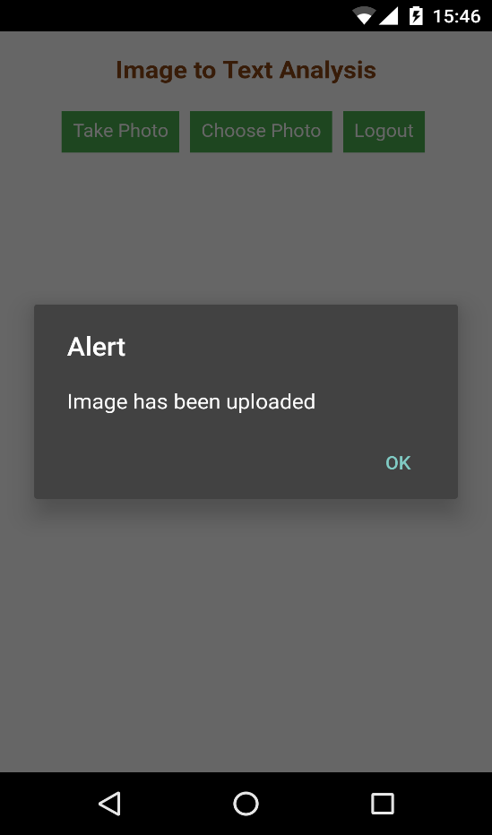 

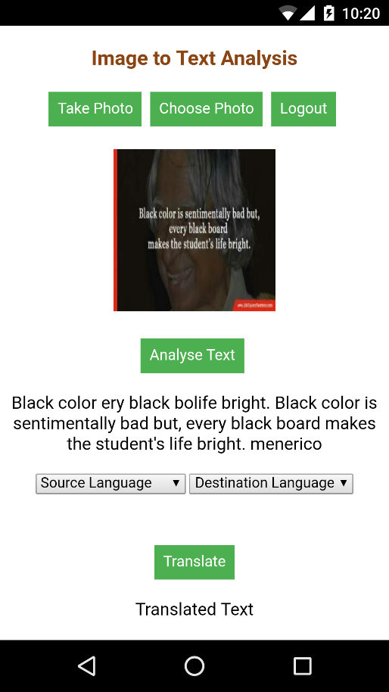 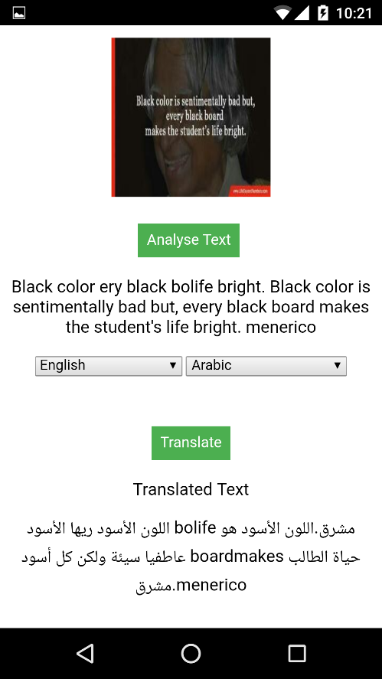

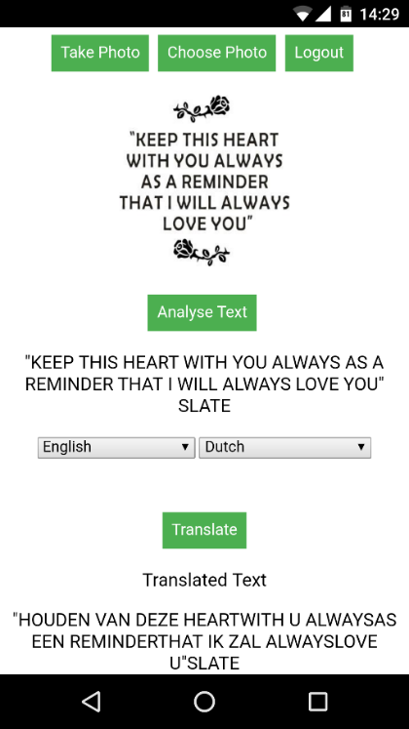

1. **Visual Recognition:**

Visual Recognition is used to get meaningful insights from an image so that tourist will be able to get useful data from an image like a traffic signal which would be useful for better understanding of various situations. User must choose a file from the device so that he can get insights from the image.

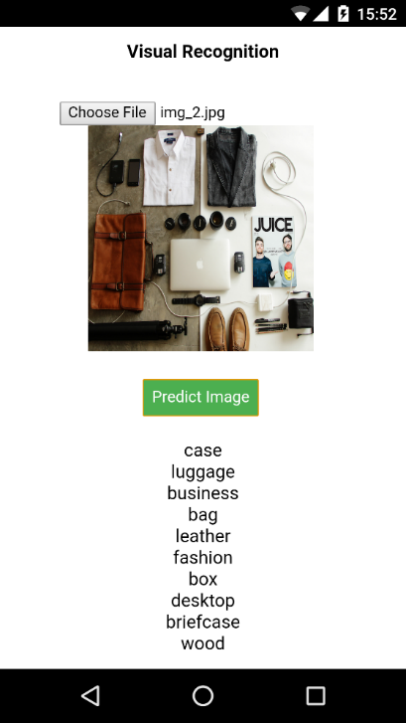 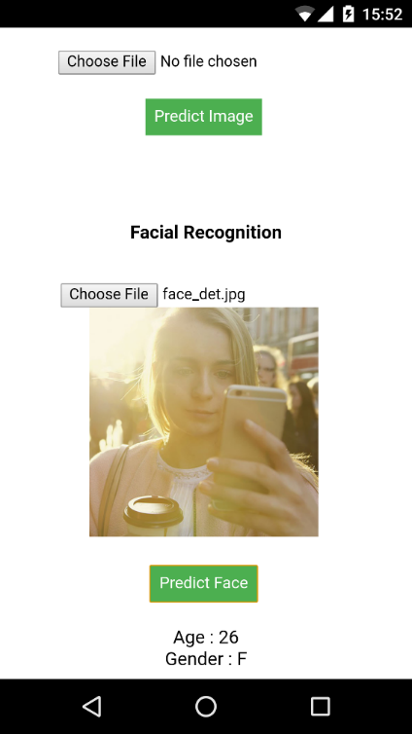

1. **Translation:**

This tab is used to translate the text from tourist native language to the preferred language so that the barrier of communication can be overcome with this service in the application.

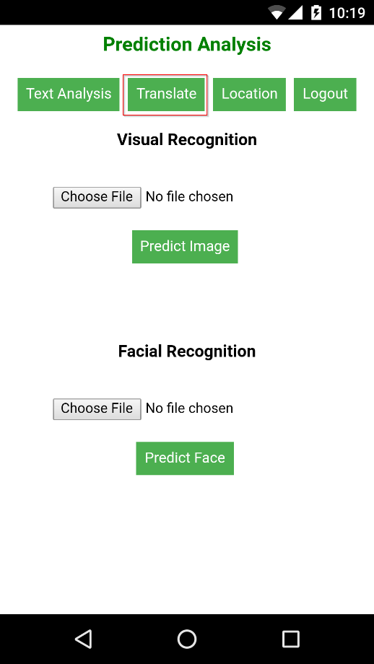 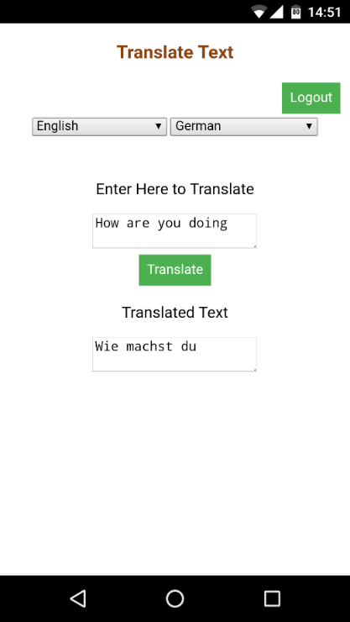

1. **Maps**

Maps is used to locate the location of the tourist so that he can find and track the movements without opening any other application for his location.

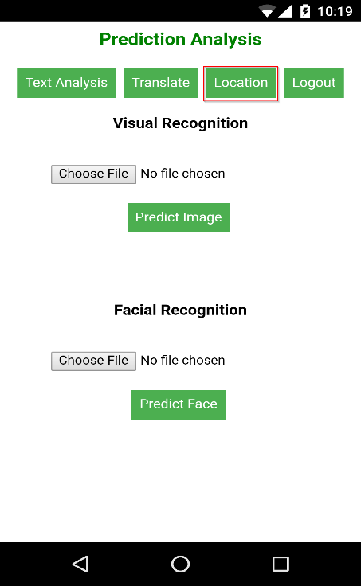 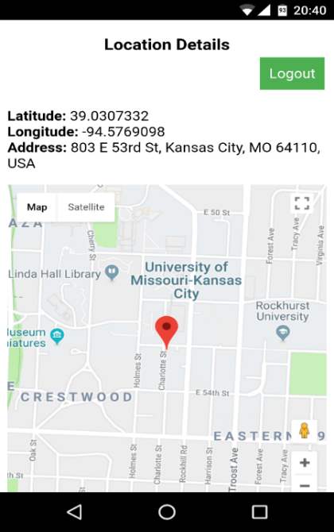

1. **Speech:**

Speech tab is used to translate the text that is translated so that the local people can understand.

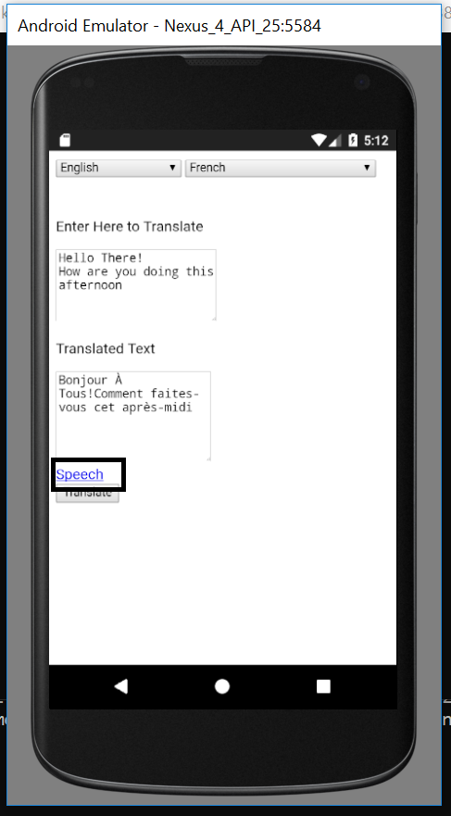

**Heroku Cloud Deployment**

The project has been deployed into the Heroku cloud server

Heroku Cloud URL: [https://hidden-garden-97186.herokuapp.com/](https://hidden-garden-97186.herokuapp.com/%20)

**Augmented Reality**

Designed, Developed and implemented the Augmented Reality application with Vuforia and unity. This application will detect the sign posts and convert into the desired language. We have trained the system to detect the word “STOP” and convert into Spanish language.

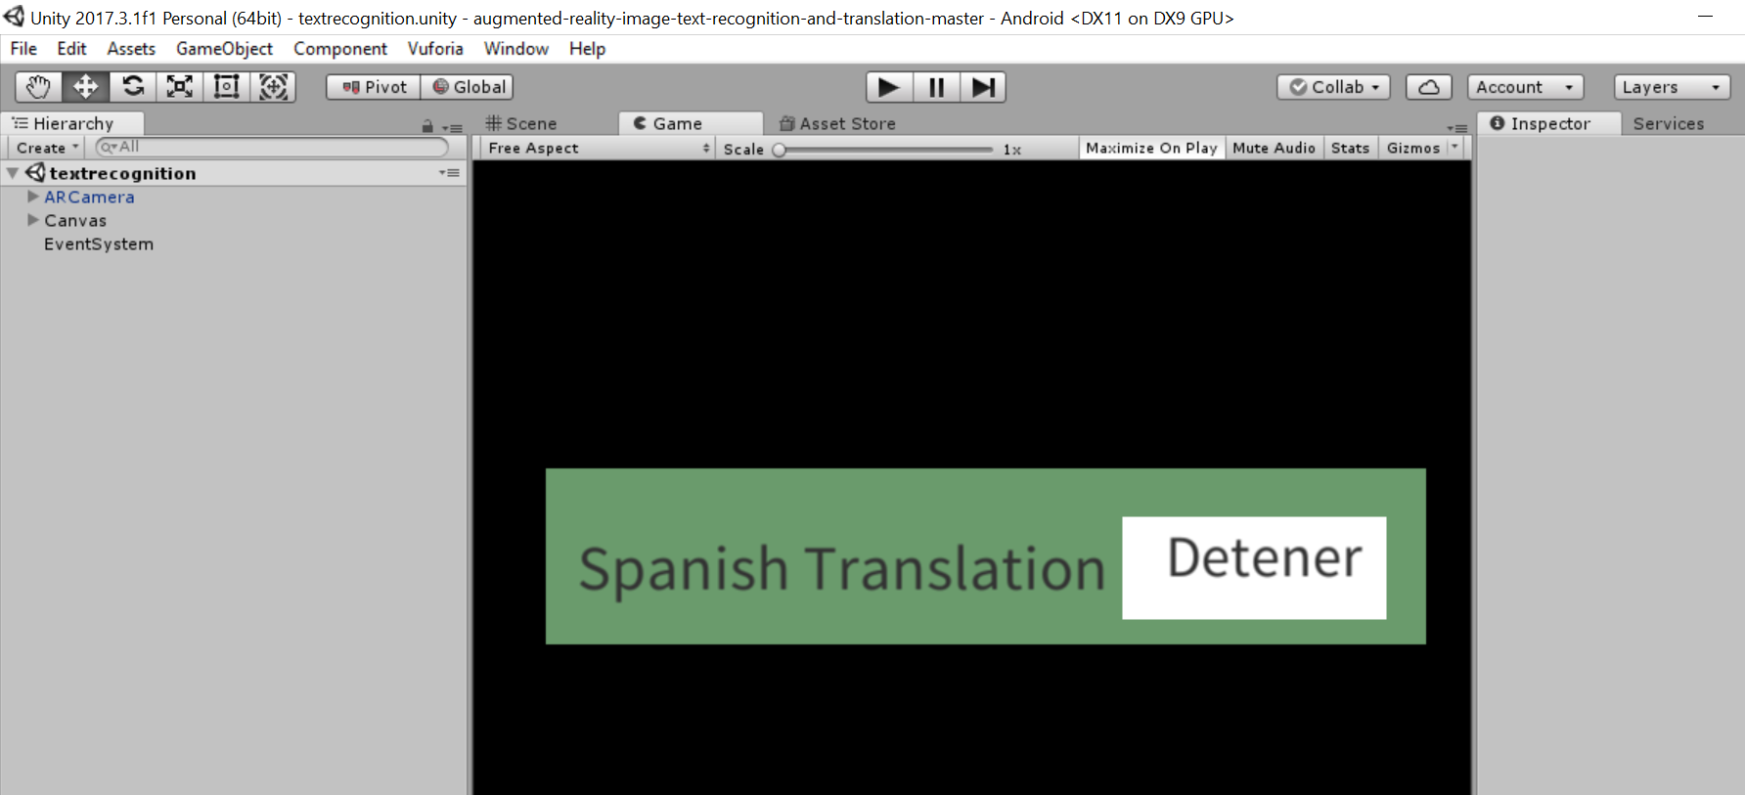

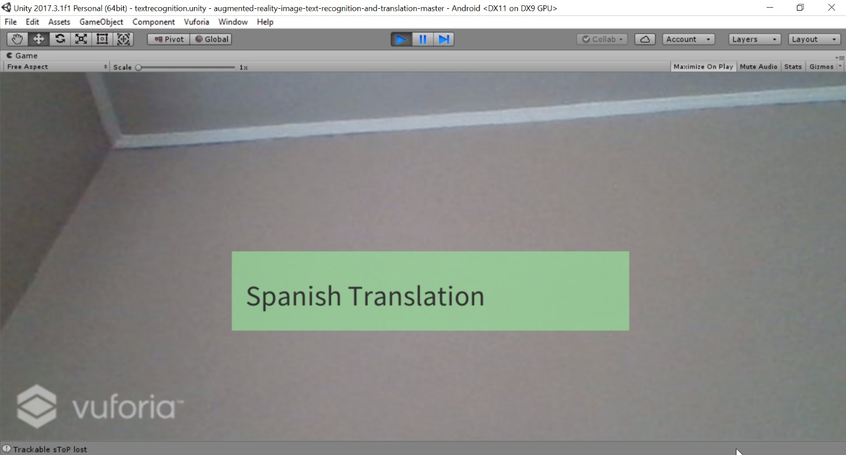

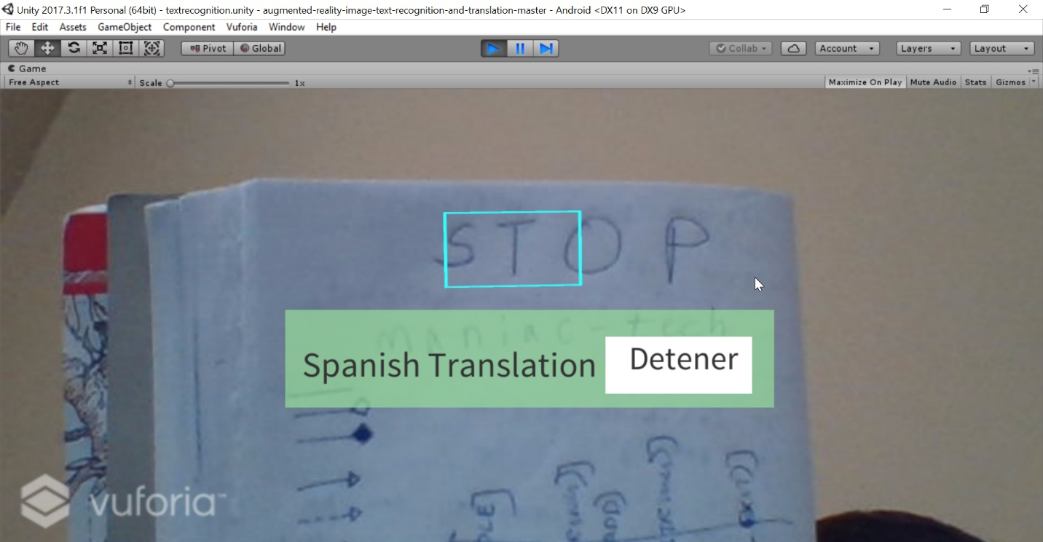

**Testing -**

**Unit Testing:** Each and every feature has been validated and is working as expected

**Performance Testing:** The performance of the entire project has been evaluated using Yslow tool which has described below

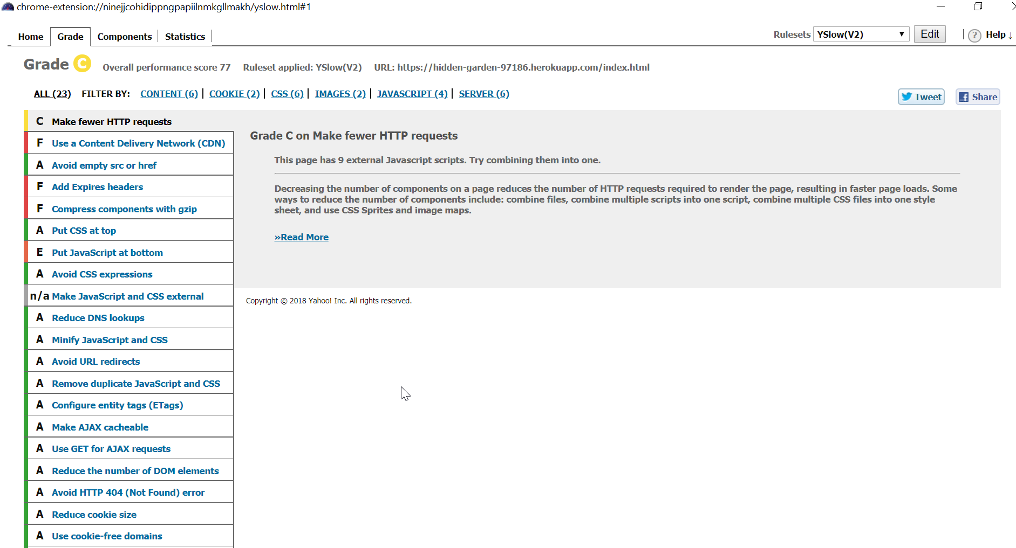

**Project Management:**

**Implementation Status Report:**

**Work Completed:**

1. **Google OCR** – In the previous iteration we have used Ionic OCR to convert image to text but due to low accuracy, in this iteration we have used Google OCR to convert images to text.

**Responsibility and Time Taken:**

* Aravind – Designed, Implemented and tested the OCR image conversion Page (24 days)

1. **Augmented Reality Application:** Developed Augmented Reality application with Vuforia and Unity. This story should be able to detect the signs and convert them into desired language.

**Responsibility and Time Taken:**

* Sharath– Design, Implementation and Testing of the translation page (24 days)

1. **Integrating Augmented Reality with Ionic:** Describes the integration of Augmented Reality Application with Ionic Framework.

* Aditya - Design, Implementation and Testing the integration of Augmented Reality (24 days)

1. **Unit & Sanity Testing:**

* Bhanu – Validated all sanity and unit test cases for the entire application (16 days)

**Concerns:** We are facing issues while integrating the Vuforia-Unity application with Ionic framework. The following are the references of GitHub I followed: [**https://github.com/yasirkula/UnityIonicIntegration/blob/master/README.md**](https://github.com/yasirkula/UnityIonicIntegration/blob/master/README.md)

**Future Work:** Analyzing Twitter Social Media content is the pending story and will be completed in future.

**Sprint Burndown Chart:**

